Ways to Implement Civilize It: Dignity Beyond the Debate
Last year Catholic Charities of Louisville launched the Be Golden campaign, inviting all throughout the Archdiocese to “Do to others what you would have them do to you.” This is a rallying cry to unite under this message and practice messages of unity, civility, and empathy every day.
As we enter into another major political campaign, the U.S. Bishops have launched the Civilize It campaign, which is a perfect extension of Be Golden. As Catholics, we have a long tradition of engagement in the political process as a means of putting our faith into action. We are called to bring the best of ourselves and our faith to the public square—and yet today, many shy away from such involvement because our national and local conversations are filled with vitriol and harsh language, often directed at people themselves.

When personal attacks replace honest debate, no one wins. This kind of attack, no matter the reason, only serves to further divide our communities. As Catholics, we must model a better way. We invite you to join the Civilize It campaign by taking the pledge below as a way to promote civility, love our neighbors, and build community.

We have shared some practical suggestion to implement this below. We invite you to share other ideas. Send your suggestions and questions to Deacon Lucio Caruso at Catholic Charities, lcaruso@archlou.org.

- Launch an effort to invite parishioners to sign the pledge for civility. Email and bulletin language to invite parishioners can be found on the next page. The pledge can be found at www.civilizeit.org.
- Introduce the Prayer for Civility and the pledge at key parish meetings and invite parishioners to participate.

- Periodically pray the Prayer for Civility at parish liturgies.

- Invite your social outreach and/or respect life committees to host a community or parish event around civility and love of neighbor. Encourage people to join Civilize It and pledge civility, clarity, and compassion this election year. Let us know how it goes! Use this two-question reflection with those in your faith community and share the responses with us; your parish may be featured in future promotions of Civilize It, as well as in The Record.
Why are you pledging to Civilize It this election year?
What is one concrete step you will take to show dignity beyond the debate?

- See the following pages for social media information posts and graphics that can be shared on parish platforms.

- Invite your formation committee to hold sessions to review the USCCB Forming Consciences for Faithful Citizenship document and educate parishioners about conscience formation. This attachment describes this process of conscience formation and provides some questions for reflection. Video and print resources that provide a summary of Forming Consciences for Faithful Citizenship also have just been approved by the U.S. Bishops and will be available at www.usccb.org.
Short Promotional Blurb
What does it mean to love our neighbors in the midst of such a divisive climate? Catholics are called to bring the best of ourselves and our faith to the public square—and yet today, many shy away from such involvement because our national and local conversations are filled with anger and harsh language, often directed at people themselves. As Catholics, we must model a better way. We invite you to model love for neighbor by pledging to Civilize It and committing to civility, clarity, and compassion this election year. Civilize It: Dignity Beyond the Debate is a non-partisan call to focus on the dignity of all people, even those with whom we disagree, and to put faith in action. Make room in your heart for those with whom you disagree and pledge dignity beyond the debate today at CivilizeIt.org!
Bulletin Insert
Use this bulletin insert to encourage people in your diocese to pledge civility, clarity, and compassion this election year.
Sample Email Announcement

Dear [Name],
With another election cycle in full swing, we are faced with the difficult question of what it means to love our neighbors in the midst of such a divisive climate. We are called to bring the best of ourselves and our faith to the public square—and yet today, many shy away from such involvement because our national and local conversations are filled with anger and harsh language, often directed at people themselves.
When personal attacks replace honest debate, no one wins. This kind of attack, no matter the reason, only serves to further divide our communities. As Catholics, we must model a better way. In response to this need, the United States Conference of Catholic Bishops (USCCB) has launched a year-long campaign calling for civility throughout this election year. Civilize It: Dignity Beyond the Debate invites Catholics to pledge civility, clarity, and compassion in the public square and to call on others to do the same.
[Name of Parish] is challenging Catholics to model love for neighbor through respect, and compassion during the 2020 election cycle and beyond. Put your faith into action and make room in your heart for those with whom you disagree. Pledge dignity beyond the debate today at CivilizeIt.org!

Sample Social Media Messaging

Facebook and Instagram – Tag us! @WeAreSaltandLight & @USCCB
- What does it mean to love our neighbors in the midst of such a divisive climate? This election year commit to dignity beyond the debate with #CivilizeIt: CivilizeIt.org. #CivilizeIt2020
- We are called to bring the best of ourselves and our faith to the public square—and yet today, many shy away from such involvement because our national and local conversations are filled with anger and harsh language, often directed at people themselves. As Catholics, we must model a better way. #CivilizeIt this election year by pledging civility, clarity, and compassion: CivilizeIt.org #CivilizeIt2020
- #CivilizeIt is a non-partisan call to focus on the dignity of all people, even when we disagree, and to put faith in action by bearing witness to a better way forward. Make room in your heart for those with whom you disagree and pledge dignity beyond the debate today at CivilizeIt.org! #CivilizeIt2020
- When personal attacks replace honest debate, no one wins. This kind of attack, no matter the reason, only serves to further divide our communities. As Catholics, we must model a better way. How can you model love for neighbors through clarity, civility, and compassion during the 2020 election cycle? Put your faith into action and pledge dignity beyond the debate today at CivilizeIt.org! #CivilizeIt #CivilizeIt2020
Twitter – Tag us! @WeAreSaltLight & @USCCB
- Bring the best of yourself and your faith to the public square by honoring the human dignity of all you encounter, even those with whom you disagree. Pledge to #CivilizeIt today: CivilizeIt.org! #CivilizeIt2020
- Pledge dignity beyond the debate this election year. Join #CivilizeIt2020 and commit to civility, clarity, and compassion this election year: CivilizeIt.org. #CivilizeIt
- Will you pledge dignity beyond the debate? #CivilizeIt this election year: CivilizeIt.org #CivilizeIt2020
- Put your faith into action and make room in your heart for those with whom you disagree. Sign the #CivilizeIt pledge today! CivilizeIt.org #CivilizeIt2020
- When personal attacks replace honest debate, no one wins. Model a better way with #CivilizeIt and promote civility, clarity, and compassion in your community: CivilizeIt.org #CivilizeIt2020
- As Catholics, we are called to encounter others, even those with whom we disagree, with an open heart and well-formed conscience. #CivilizeIt and bring your best self and your faith to the public square: CivilizeIt.org! #CivilizeIt2020

Sample Social Media Graphics
To save graphics, right click each one and select “save as picture”

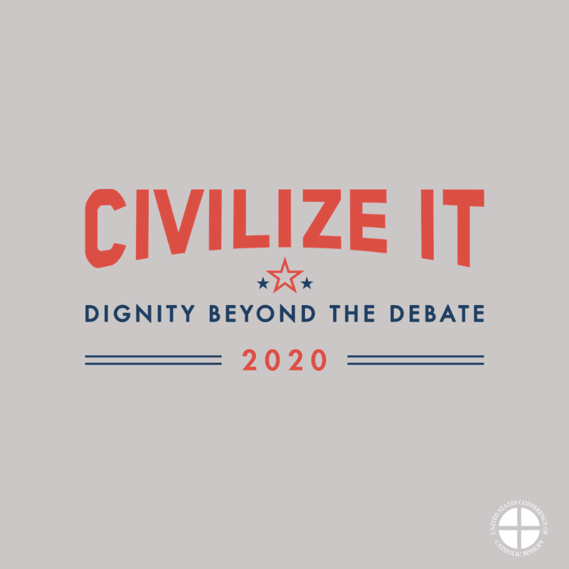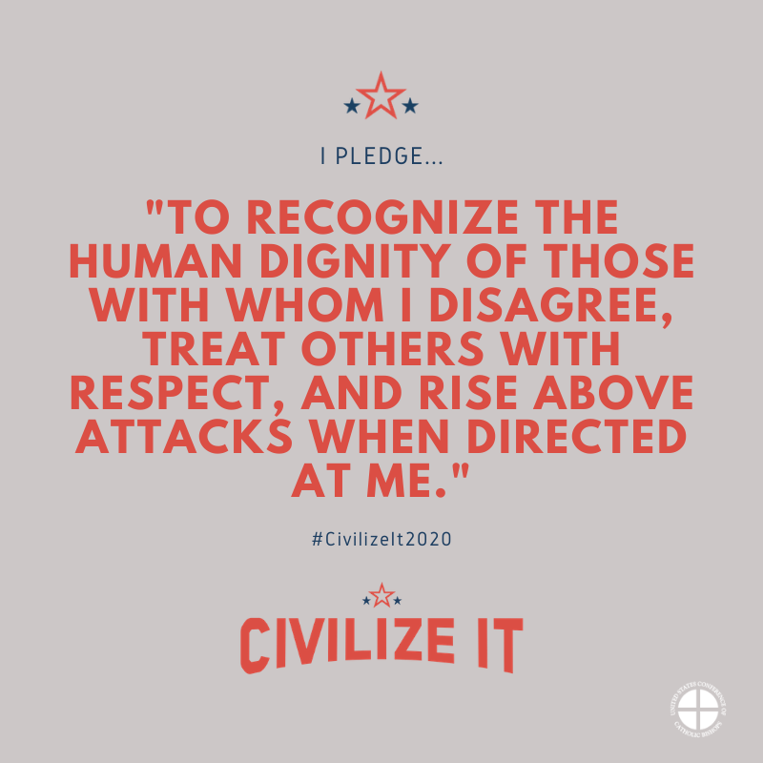

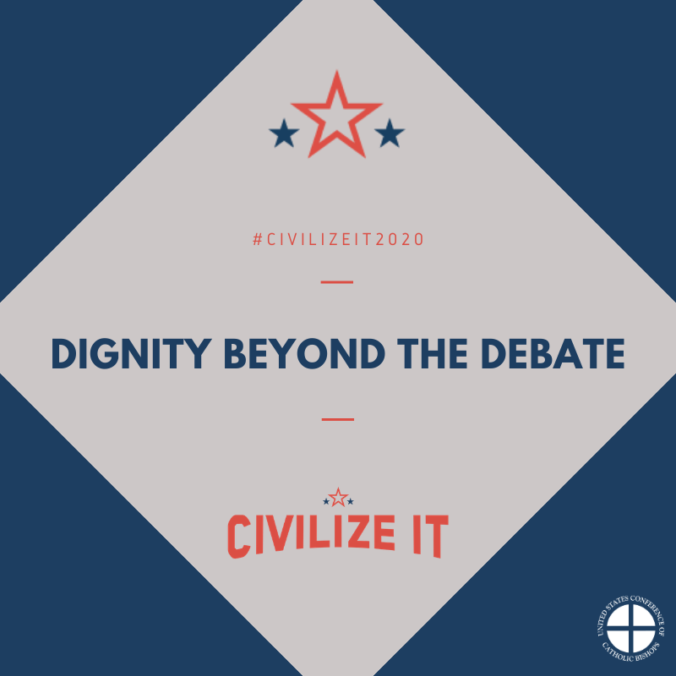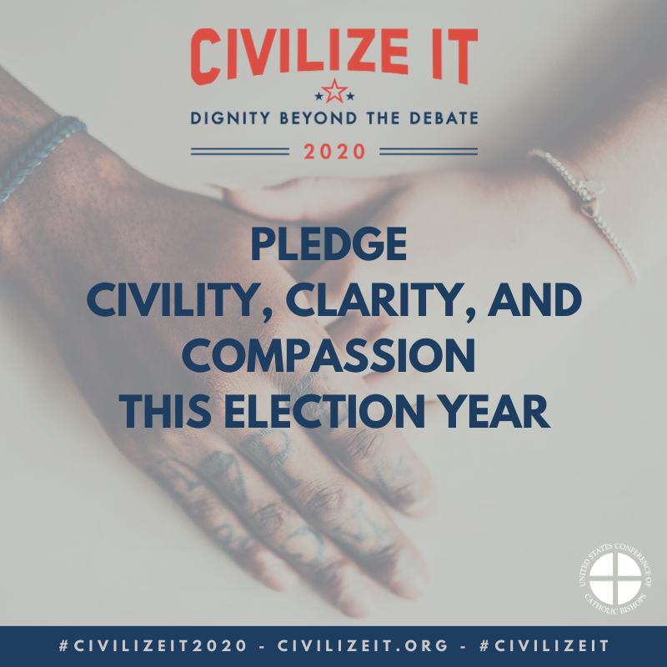
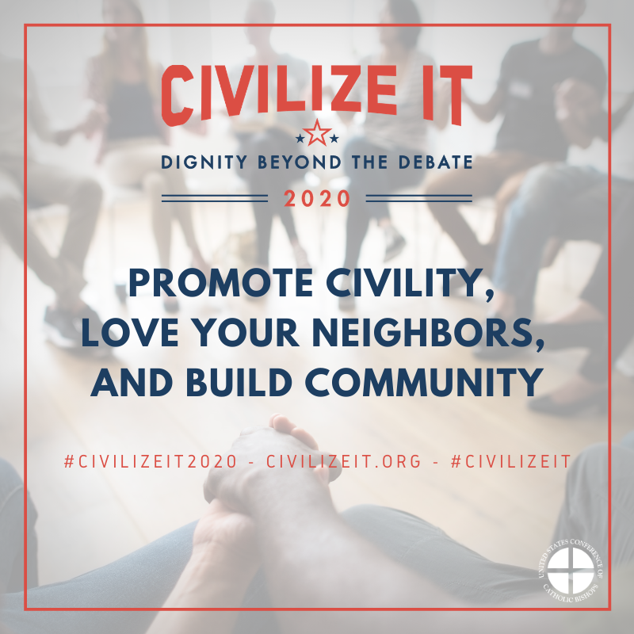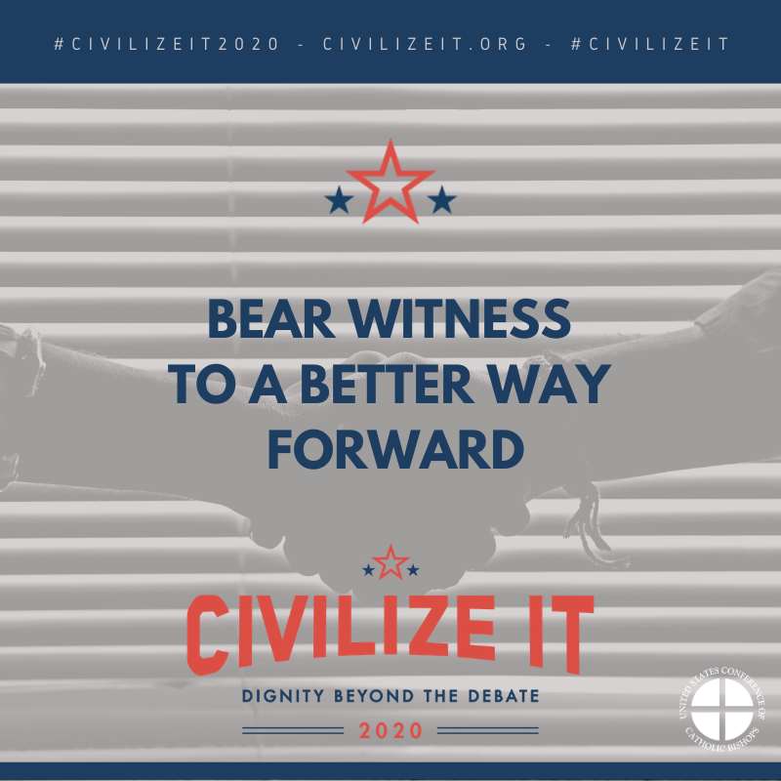

Social Media Banners
To save graphics, right click each one and select “save as picture”

Facebook:

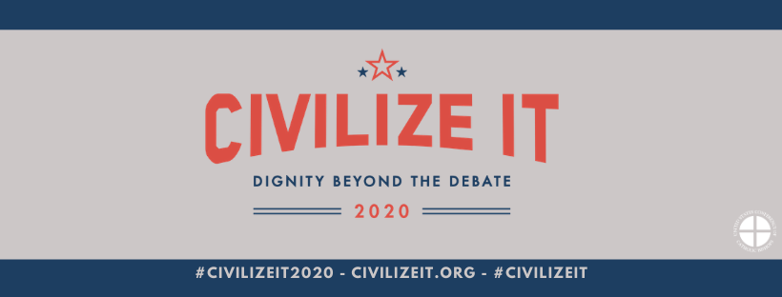

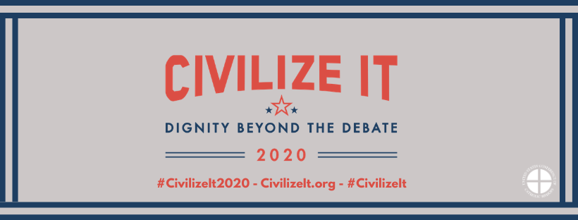

Twitter:

