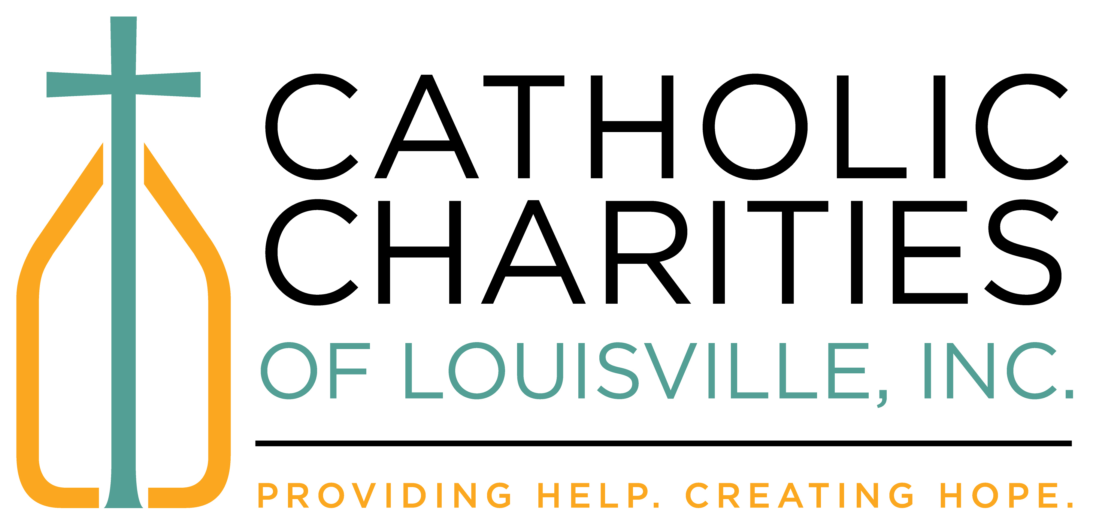
Healthy at Work
Plan to Reopen Agency Offices May 2020

Catholic Charities is a dynamic and complex organization with wide array of services and obligations to various funders and other governing bodies. Therefore, we all must understand that this plan cannot be a “one size fits all” document. This is the establishment of guidelines for departments as we begin to reopen our facilities to staff and clients.
Flexibility will be key in thinking about how we will continue to do our work in a healthy and safe environment while unforeseen circumstances are certain to arise. As such, we all should be aware that this is a living document. When situations within the agency or local and state guidelines change, we will continue to evaluate and adjust our plan accordingly. Any questions or concerns about the content or execution of this plan should be expressed to your supervisor / program director to be brought to the attention of the Leadership Team.
Catholic Charities is made of a caring staff which performs important meaningful work to some of the least among us. We are in the midst of conditions which none of us have experienced before while at the same time trying to address unimagined problems usually with limited information or resources. This will take all of us working as a team to succeed. It will not always be easy, but by giving the benefit of the doubt and being patient with ourselves and especially each other, we will get through together.

- Returning to Work
Catholic Charities will not be returning to “business as usual” on May 18. We will be initiating a phased reopening with limited staff and client interaction for the next several weeks. Kentucky guidelines state that remote working is still best and staff should continue to work remotely as they are able. Supervisors should be in close consultation with their staff to establish whether and how to continue to conduct work remotely or in person.

  - Scheduling
Program Directors will manage appropriate staffing levels within their departments based on these guidelines and determine their subsequent service capacity. These plans will be provided to and monitored by the Director of Programs.

  - Staff Health
Per state guidelines, employers should not be conducting health checks or recording medical information. Employees are expected to monitor their personal health. Staff should not report to work if they do not feel well, have a fever or have any other COVID-19 symptom. In this case, the employee should arrange for a COVID-19 test through available resources. (Please note that COVID-19 tests are covered without co-pays through our health insurance.)

- Permissible Numbers of Staff
As a general rule, staffing should be coordinated to limit each floor per building to four employees at a time to allow for social distancing. Building configuration may allow for exceptions. Departments sharing floors in buildings will need to communicate and coordinate schedules with each other to ensure the total number of staff members so proper distancing can be maintained. Requests to alter permissible staffing levels will be submitted to the Director of Administration to be evaluated by the Leadership Team.
  - 2911 S. 4th Street – up to 12 staff (4 per floor)
    - 1st Floor – 2 Administration and 2 Family Support
    - 2nd Floor - Schedule Executive Office, Dir. Programs, Development, Mission, and Ombudsman
    - 3rd Floor – Schedule Language Services, Immigration Legal Services, Dir. Administration
    - Elevator – Using the stairs is best, but only one person may be in the elevator at any time

  - Sister Visitor Center – up to 6 staff / 4 volunteers (4 per floor/ area)
    - 1st Floor (Offices) – 1 Reception, 2 Caseworkers, 1 Facilities
    - 1st Floor (Warehouse) – 2 Clothing, 2 Food
    - 2nd Floor – 1 Director, 1 open office

  - St. Anthony Friary – up to 8 Staff (4 per floor)
    - 1st Floor – Schedule Reception, Director, Donations, Youth Services
    - 2nd Floor – Schedule Employment, Benefits, Case Management, Special Services

  - St Anthony Convent – up to 9 staff (3 per floor)
    - 1st Floor – 3 Finance Staff
    - 2nd Floor – 3 KOR staff
    - 3rd Floor – Schedule KOR, Common Earth, Common Table

  - St. Anthony School
    - BEI – no more than 3 (staff/clients) in office at any one time
    - ESL – no ESL until further notice; no more than 3 (staff/clients) in any room at one time
    - Gym – staff activities requiring interaction but allowing space for proper distancing (i.e., meeting with other staff, clients, or vendors)

- Interpersonal Interaction and Facilities
The following guidelines will be followed within agency offices so that we are operating in a healthy and safe manner.

  - Social Distancing
All staff and clients will remain the recommended minimum distance of 6 feet away from each other at all times. Limited exceptions may be for the hand transfer of items, however, care will be taken to make the exchange as brief as possible and to minimize any exposure.

  - Personal Workspaces
Clients and coworkers will refrain from entering any staff person’s private office. For cubicles or other open workspaces the recommended 6 feet of distancing will be maintained.
  - Staff Kitchens / Break Rooms
Staff will refrain from congregating, lingering, or eating in these areas. Staff may access these areas for only the time necessary to utilize appliances for storing or preparing food and beverages and hand washing.

  - Waiting Areas
Chairs/Seats will be removed from agency waiting areas to ensure appropriate distancing can be maintained by clients.

  - Internal Meetings
Staff should continue to avoid in-person meetings as possible. Prior to conducting these meetings, staff should consider if meeting in person is necessary or can the activities be conducted virtually or over the phone. Staff will not meet in person if all social distancing and other safety precautions are unable to be followed.
  - Client Appointments
Staff will continue to make every effort to conduct business virtually or over the phone. Any client being received for services within Catholic Charities offices will have been scheduled for an onsite appointment by staff. No walk-in appointments will be accepted except for emergency food distribution by SVC.
  - Receiving Clients
For instances wherein virtual services are not possible, staff will maintain appropriate distancing when meeting with clients. It is not required to monitor the temperature of clients, however, a program may make its own arrangements if it chooses to do so. These interactions are limited to one staff member and any clients who currently reside together in the same household. Any interpretation required will be conducted by bilingual staff or via telephone. To accommodate this, larger common areas such as conference rooms will be utilized for these interactions.
    - Immigration Legal Service clients will use the 1st Floor conference room at 2911
    - MRS clients may use the MRS and ESL conference rooms
    - SVC will continue present food distribution protocols
Programs should be mindful of these limitations and only schedule the appropriate number of appointments that can be accommodated in these areas at any one time.

  - Group Sessions and Educational Classes
All in-person group and class setting services (i.e. Mother-Infant Care, ESL Classes) will continue to be suspended until further notice.

- Personal Protective Equipment - PPE
PPE will be provided to staff per Kentucky guidelines, however, PPE is not a substitute for proper distancing and hygiene protocols. Staff should always keep the recommended distance from others, wash their hands regularly, and avoid touching their face – especially their eyes, nose, and mouth.

  - Masks - Staff
Each staff person will be provided two washable cloth masks to be used while in the office. It is the responsibility of the staff person to ensure they have their mask when coming to the office and to properly use and maintain it. Instructions for use and care will be provided. Masks will be worn by staff at all times except while in a private office.

  - Masks - Clients
A limited supply of disposable masks will be at the 2911, MRS, and SVC reception areas. These may be provided to clients in the event they are not appropriately masked, however, when making appointments staff should communicate to clients that masks are necessary when coming to our offices.

  - Gloves
Gloves will be made available for use by staff who interact with highly touched items such as cash or credit cards. Since the virus cannot be contracted through the skin, gloves should neither be continually worn, nor be used while performing any other activities besides interacting with the above-mentioned items. Continually wearing gloves as opposed to the intended one-time use is counterproductive and does not result in a decrease of exposure as it discourages hand washing thus promoting cross contamination.

- Sanitization
The Facilities Department currently does not have assistance from Dismas workers, but will ensure common areas are regularly sanitized.
  - Hand Cleansing
Disinfecting stations and soap dispensers will be regularly monitored and stocked as supplies allow for proper hygiene while in the office. Staff are encouraged to wash their hands regularly for at least 30 seconds, especially after transitioning from outside or using frequently touched items such as door handles and elevator buttons.

  - Personal Workspaces
Staff will be responsible for sanitizing their own personal workspaces (i.e. keyboards, phones, desks, etc.). This is to keep additional staff out of your office to reduce the risk of cross contamination. Disinfecting solution and paper towels will be available at numerous stations throughout our buildings for wiping down personal workspaces.

  - High Traffic Areas
Spaces with frequently touched items such as hallways, restrooms, waiting areas, and entry ways will be sanitized by facilities staff at least twice during the work day.
  - Kitchens
Staff are encouraged to disinfect these areas as they feel comfortable after use (i.e. refrigerator handles) to assist in the reduction in the spread on the virus.

- Compliance
All staff and clients will be expected to comply with these guidelines. Any non-compliance should be immediately reported to the COVID Response Manager for immediate action and resolution.

