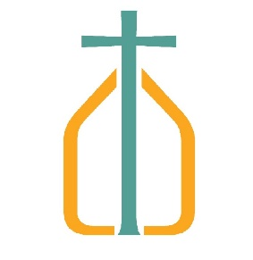
CATHOLIC CHARITIES OF LOUISVILLE
Language Services:

Out of continuing concerns for the well-being of our staff, Language services will be working remotely till further notice. But we are available to answer your questions, provide interpreting and translation services.

Regarding translation, all requests must be emailed to Nurio Ahmed at Nahmed@archlou.org. The email must contain:
- your name
- phone number
- written language of the document
- the target language you want the document translated to
- a legible copy of the document.

Our business hours have not changed, so please reach out with any questions you may have.

502-637-9786
Monday - Friday
8:30 am to 4:30 pm

