LEADERSHIP MEETING
MINUTES
6/15/2020
Discussion Items:
- All Staff communication: Lisa has prepared for this week, but in a week or two it will move to someone else from the Leadership Team.
  - Lisa will be on vacation at the start of July, so if not sooner, it will definitely happen then.
- Voter access: there’s a lot of concern about the shortage of poll workers causing polling places to be closed and thus reducing voter access. What if we pay staff who volunteer as poll workers? Lisa will talk about this with Vetta.
- Leadership Team FY2021 goals (as set in evaluations) were shared in the group. Board will be reviewing Year End report on last year’s challenges, and discussing challenges the agency will face in FY 2021. Ideas from the Leadership Team?
  - Lucio notes that the agency has made a lot of progress on improving public profile, though there is still work to be done.
  - Ellen observes that fund-raising is going to be a challenge with the current upheaval. Many foundations are not accepting regular funding requests, only COVID response; can’t say what events will look like.
  - Becky comments that the November 2020 election is going to be enormously significant for several programs, no matter what happens. We will have to be prepared to respond one way or the other.
- Possible All Staff survey in July? Is it time to do this again?
  - When Lisa came three years ago, we did an employee satisfaction survey. 52 people responded – which was pretty good return for a staff of 85-90. We’ve done a lot of culture work and also had a lot of employee turnover in that time.
  - Bart will pull up the old Wufoo survey and run the results again.
  - We should ask many of the same questions to see change in the answers but there might be new things to add.
- Possible Mission virtual lunch on racial justice. Another Catholic Charities used a video of Archbishop Gregory (Washington DC) speaking on racism and launched a discussion.
  - The Leadership Team must be willing to be uncomfortable. We have to demonstrate that we are committed to the need for change, to model openness for the topic to all staff – people of color and white employees.
Updates:
LISA
- Board of Directors will meet this Wednesday. Five new candidates for Board seats will be presented.
- Working on goal-setting for agency and me personally for FY 21.
- Participated in discussion with local non-profits around diversity, equity, and inclusion efforts. What good ideas can we make use of here? How can we better coordinate?
BART
- Ron will be out on medical leave for approximately 10 weeks. This is a tough time for this to happen and we still have no word when the Dismas crew will return. We are currently seeing about getting Tony some temporary help during this time. We will certainly maintain the appropriate disinfecting in regard to COVID, but I would like to ask for patience from the staff when dealing with other non-emergency facility matters during this time. Things will not be ignored, however, work will need to be prioritized.
NICK
- New chart of accounts building is underway along with a new database for MIP -- this will take effect July 1
- Budget and Chart of Accounts training is being planned and will occur towards the end of the month or first week of July for program directors.
- Continued work on external audit.
- Month end close is wrapping up.

ELLEN
Catholic Charities Virtual World Refugee Week is here. June 15th – 20th.
- There will be 4-5 post a day on Facebook and Instagram. Our WRD page will also have links.
- Videos include: Archbishop Kurtz, Mayor Greg Fischer, Dr. Neeli Bendapudi, Coach Walz & Louisville City FC and extra performances as well.
- Please share our posts! Greater impact we’ll have. World Refugee Day is a great learning opportunity for our community.
- We will collaborate with KRM on Saturday, June 20. KRM will live stream from 5- 8pm on their Facebook page! They are planning to feature some of our staff and our posts, including Mohamed Kerow & Zeljana Javorek.
- WLKY is going to post a video every day at 5:30 and maybe even one at noon. Colin and Darko will be on WAVE3 tomorrow on the 12:30 pm news.
- Thank you to the entire committee and all those who took pictures helping to create this unique virtual celebration!

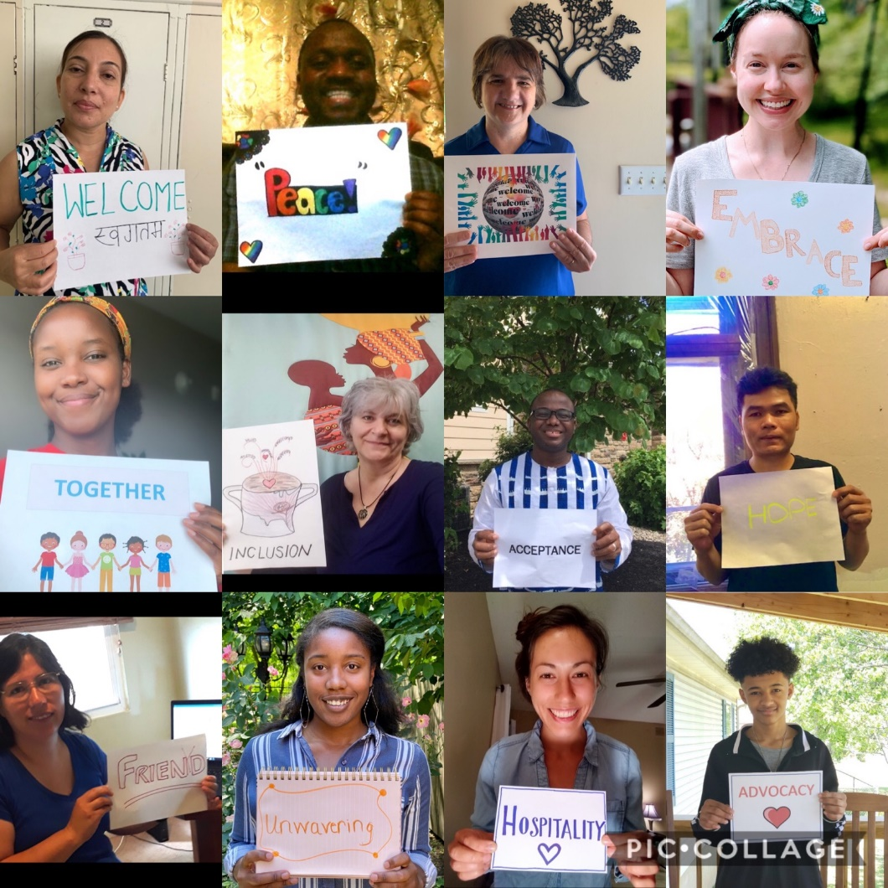

LUCIO
- Interviews of finalists for Mark's position and our new Hispanic Services Coordinator are scheduled for this week.
- Working with Cecelia, Donna Young, the St. Vincent de Paul Conference Parish liaison, to get the word out on our additional available Covid-19 assistance funds from Metro & CFL. Metro is limited to specific clients, who I refer to Shalah. CFL can be used for organizations like parishes, but not outside of Metro Louisville.
- I am in touch with Ruby and Marnie from the Record to do a series of stories from our downstate Covid-19 assistance efforts; similar to what we are putting in our newsletter, but with more detail. We have received great reports with stories and pictures.
- I have connected with Sr. Sarah and Fr. Chandler in the Vocations Office to share how our agency can help seminarians, as well as new priests to our country, who need help with English. I told them that we have materials/books to share and that any are welcome to join our ESL classes, once resumed.
- National CCHD – Archbishop signed off on CLOUT and CCL, but went with the $40,000 figure, that was recommended by the national office. I was not happy with this, as this will be the last year of the grant and I wasn't given advance notice of the reduction. I will work with Nick on some ideas to make up the 10,000.
BECKY
- KOR staff are primarily working on the WF TANF Coordination grant due on June 26, 2020
DARKO
Common Table
- We have mostly moved in the new space.
- We will aim to finish up the current soup subscription starting next Wednesday so that we can begin a new subscription the beginning of July. We are working with current subscribers to identify convenient pickup locations and will be reaching out to parishes to see if they are interested in hosting a subscription.
- The week of 6/15 we will also be testing and finalizing recipes for the new catering menu.
- We are speaking with organizations in the Parkland neighborhood including the Boys and Girls club and Change Today Change Tomorrow about how to best use our resources to address food insecurity in the neighborhood.
Common Earth Gardens
- We have spent time in recent weeks reviewing a Community Engagement to Ownership tool which has allowed us to evaluate each agriculture site and identify steps needed to move the site closer to community ownership.
ILS
- We have received news that the USCIS filing fee increases will likely be finalized in the next few months.
FSS
- FSS is now managing 2 funds related to COVID relief- Louisville Metro Council and CFL. With LMC, 29 individuals have been assisted and about $28,500 expended. With the second round of CFL, we have helped 3 individuals and 1 parish, totaling about $1,500 in assistance.
- Virtual programs will continue through the next session on MIC, which is scheduled July-August.
- SVDP has scheduled a meeting on July 1st to discuss the HUD grant for victims of domestic violence and human trafficking.
BEI
- The VOCA grant application was submitted on 6/12/20, and is written as a continuation grant, with no new activities, with a very similar budget to the current award. The Federal request amount is $150,000

- Bakhita has completed a Year 1 Annual Report describing the development and work of the Bakhita Advisory Board. This report may be helpful to other groups or organizations interested in developing an Advisory Board. Bakhita staff will pursue opportunities to present workshops about the development and work of the Board and print copies of the report. The next Advisory Board Meeting is scheduled for August but may be pushed to October. The Board will being having some meetings in the Lexington area in Year 2.

- Bakhita has completed a Prevention Education Report, providing details about the prevention education provided through the program, highlighting both the male and female curricula, statistics on group locations, facilities, numbers, and related data, and outlining additional needs in regard to prevention education. Bakhita staff will print some hard copies of the report to have available to meetings, outreach, training, etc.

- Bakhita is working with the Development Office to investigate the possibility of pursuing Alltech funding for the Labor Trafficking Conference.

SVC
- We are aiming to begin our NEW CLOTHING distribution on Friday, June 19.
- We are also aiming to take down the boarding off the windows this week if we can get our broken window repaired.

