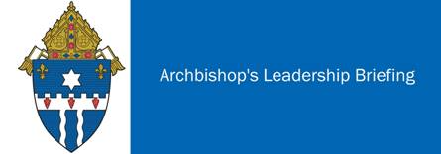
September 23, 2020 – Statement on Breonna Taylor Decision Announced Today
I again join with citizens throughout our community and the nation in mourning the tragic death of Breonna Taylor.

Whatever our reaction to decisions by the Grand Jury and the Attorney General’s Office, we must now come together to work for racial justice. There is no question that our nation’s original sin of racism continues to destroy and harm the lives of persons of color and that racism extends through so many systems of our society….educational, economic, religious, housing, criminal justice, voting, and employment.

Our Church stands ready to work with civic, community, educational, business, and non-profit partners to address these issues.

I join with people of faith and good will to plead for peace and the rejection of violence as citizens exercise their first amendment right to protest. Let us all join in prayers for Breonna Taylor’s family and friends and for justice, peace, and healing in our community.

Most Reverend Joseph E. Kurtz, D.D.
Archbishop of Louisville
September 23, 2020

