

**Email Signature Step by Step   
Instructions on All Platforms**

It is Catholic Charities of Louisville’s policy to have a uniform email signature so we present ourselves as one, unified organization.

Please see below for formatting.

Do not add additional quotes, pictures, information, etc.

**Page Contents**

2 – Desktop Application (PC)

4 – Desktop Application (MAC)

6 – Web Browser

7 – Mobile through Mail app

9 – Mobile through Outlook app

**Desktop Application (PC)**

1. Open Outlook > Create New Email > Click on Signature > On Dropdown, click Signatures

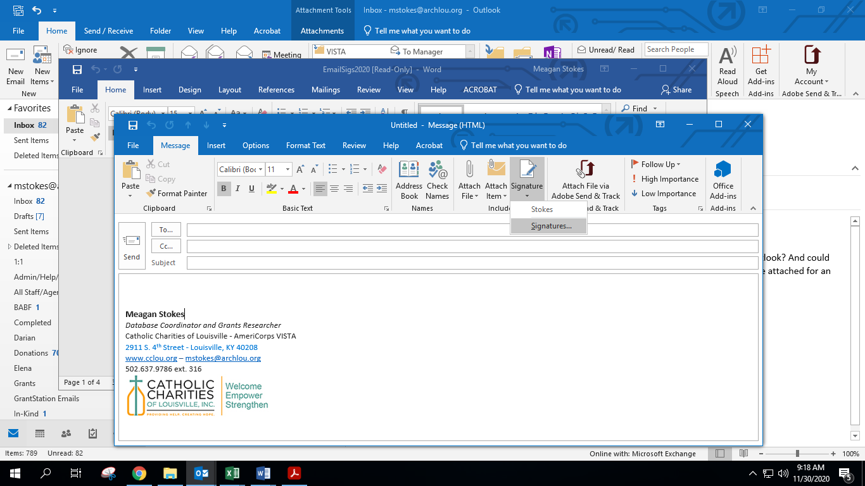



1. Click New to add a new signature and title it as you like

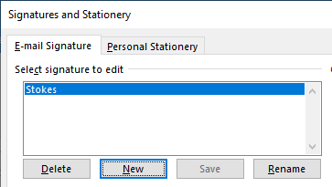



1. In the edit signature box, follow these instructions:
   1. Copy the example below and paste it into the signature box
   2. **CHANGE TO YOUR PERSONAL INFORMATION**

**Darian Decker**

*Community Relations & Marketing Coordinator*

Catholic Charities of Louisville

2911 S. 4th Street - Louisville, KY 40208

[www.cclou.org](http://www.cclou.org/) – [ddecker@archlou.org](mailto:ddecker@archlou.org)

502.637.9786 ext. 304 (W) • 812-786-1402 (C)

c. **YOU MUST DOUBLE CHECK THAT THE EMAIL LINK CORRECTLY REFLECTS YOUR EMAIL**

* Highlight your email in the signature box
* Click Edit Hyperlink button

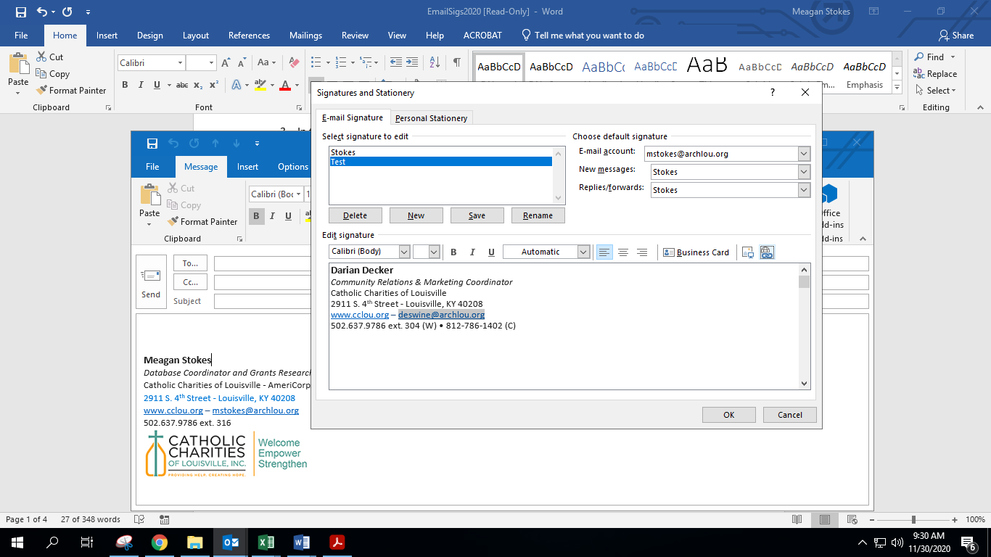



* Make sure the E-mail address is mailto:youremail@archlou.org

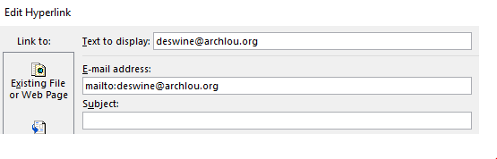



1. **Download** (do not copy and paste) the email signature image from [Employee Page/Marketing Materials](https://cclou.org/employee/marketing-materials/) > Insert Image or drag image into signature box

PROGRAMS WITHOUT LOGO (DO **NOT** CREATE ONE) 

PROGRAMS WITH AN APPROVED LOGO (side by side)

 

1. No additional quotes or information
2. Click OK

**Desktop Application (MAC)**

1. Open Outlook > Create New Email > Click on Signature > On Dropdown, click Signature or Edit Signatures  
     
   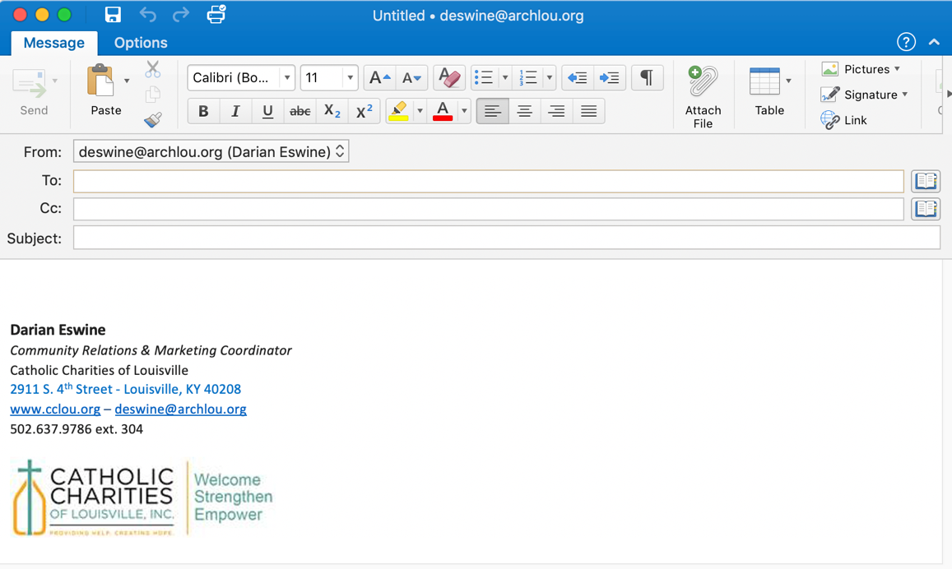



1. Click the plus sign to add a new signature and title it as you like

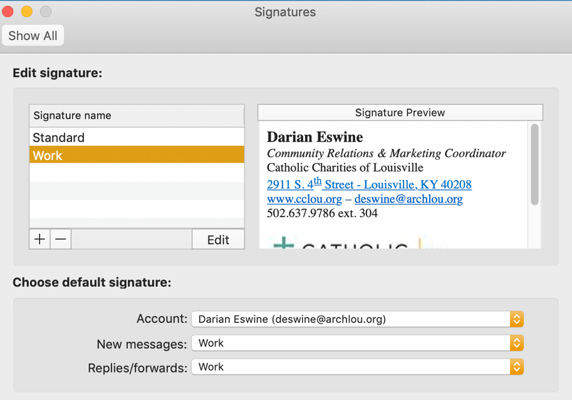



1. In the edit signature box, follow these instructions:
   1. Copy the example below and paste it into the signature box
   2. **CHANGE TO YOUR PERSONAL INFORMATION**

**Darian Decker**

*Community Relations & Marketing Coordinator*

Catholic Charities of Louisville

2911 S. 4th Street - Louisville, KY 40208

[www.cclou.org](http://www.cclou.org/) – [ddecker@archlou.org](mailto:ddecker@archlou.org)

502.637.9786 ext. 304 (W) • 812-786-1402 (C)

**c. Relink your email**

**JUST TYPING IN YOUR EMAIL ADDRESS WILL NOT WORK. YOU MUST DO THE BELOW TO RELINK IT TO YOUR EMAIL.**

* To link to your email address, highlight your email in the signature box
* Right click and choose Hyperlink > Edit Hyperlink
* Type in your email address and click OK

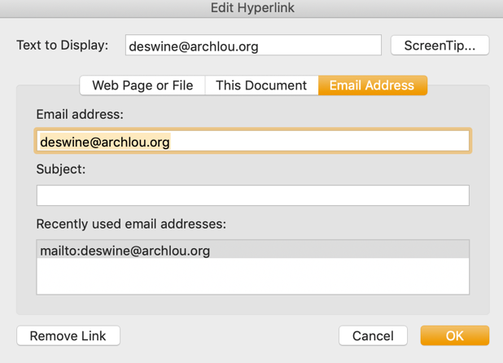



d. Click before your name in the box and hit “Enter” two times to add a space

1. **Download** (do not copy and paste) the email signature image from [Employee Page/Marketing Materials](https://cclou.org/employee/marketing-materials/) > Insert Image or drag image into signature box below your other information   
     
   **DO NOT COPY IMAGE FROM BELOW. YOU MUST SAVE THE IMAGE FROM THE LINK AND INSERT THAT IMAGE.**

PROGRAMS WITHOUT LOGO (DO **NOT** CREATE ONE) 

PROGRAMS WITH AN APPROVED LOGO (side by side)

 

1. No additional quotes or information
2. Click OK

**Web Browser Version**

1. Go to the gear in the top right corner > Options  
     
   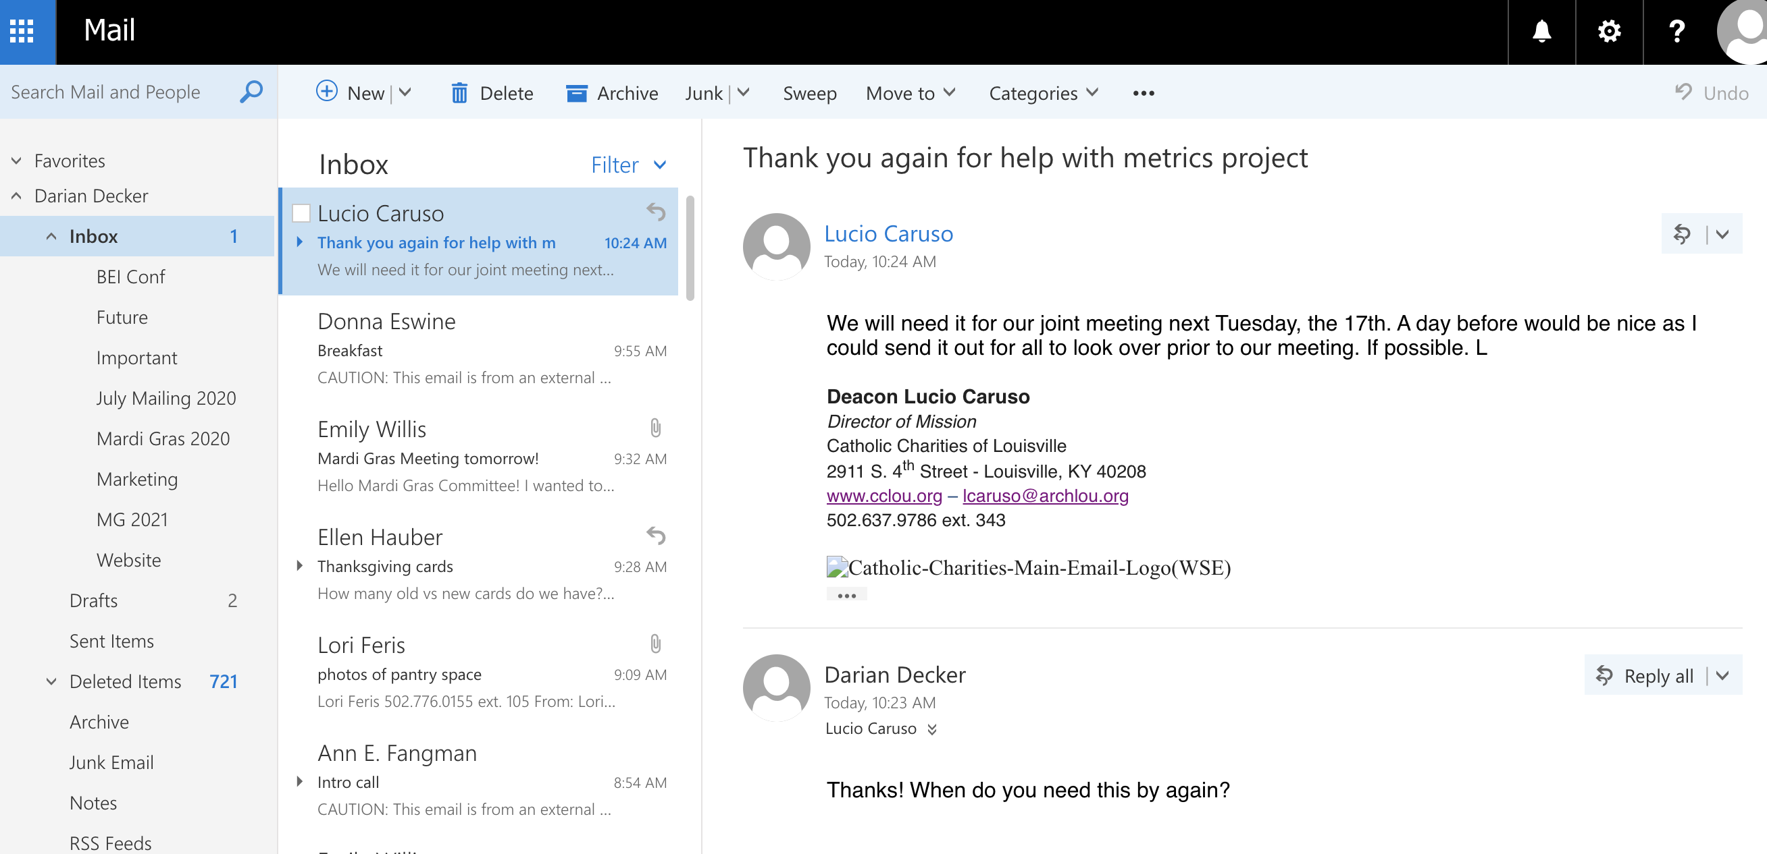



1. 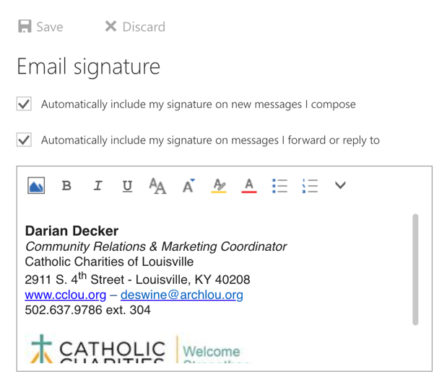In the left sidebar under mail > layout > click “Email Signature”
2. **Follow Step 3 on first page**
3. Make sure both boxes are checked



1. Save

If your signature is doing this, make sure you’ve done step 3 from the first page in full. You must download and insert the image. You cannot copy the image from this document. If you have other issues, contact Darian.

**Mobile (Smart Phone) – From “Mail” App**

1. Open Settings
2. Scroll down and tap Mail

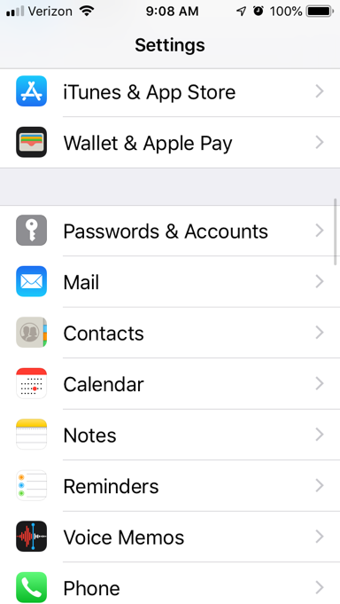



1. Scroll down and tap Signature

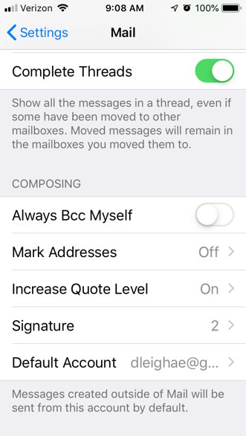



1. **Copy and paste from Step 3 on first page**
2. Make sure it’s either checked for all accounts or your work account only

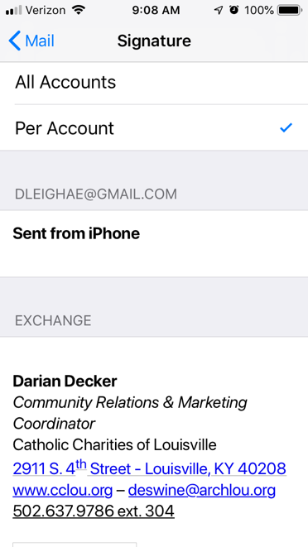



(YOU CANNOT PUT AN IMAGE IN THIS SIGNATURE)

1. Close or tap the arrow to go back to mail at the top. It will save automatically.

**MOBILE – From “Outlook” App**

1. Click on your email in the top left > Click on the gear icon in the lower left

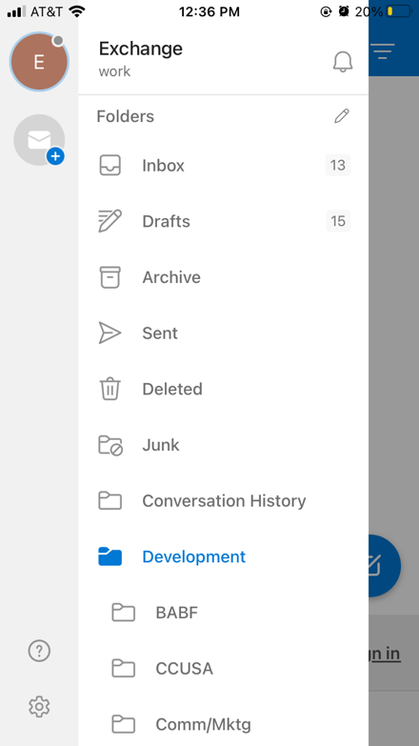



1. Click “Signature”

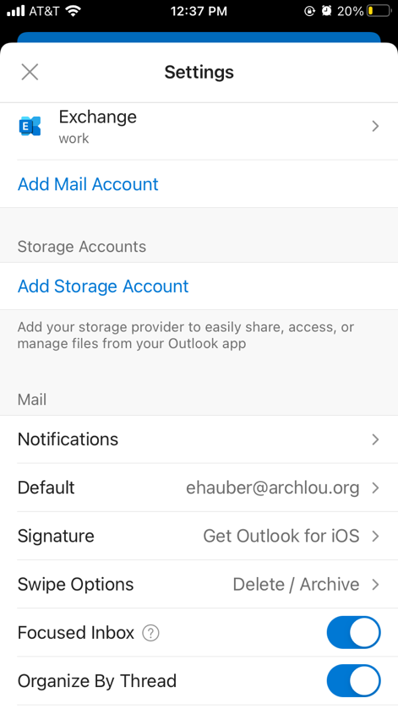



1. Copy and Paste or type in the below: **(CHANGE TO YOUR PERSONAL INFORMATION)**

**Darian Decker**

*Community Relations & Marketing Coordinator*

Catholic Charities of Louisville

2911 S. 4th Street - Louisville, KY 40208

[www.cclou.org](http://www.cclou.org/) – [ddecker@archlou.org](mailto:ddecker@archlou.org)

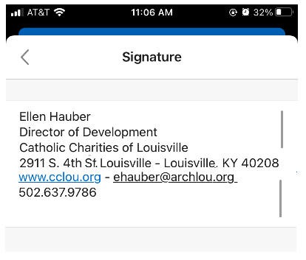

1. Close or tap the arrow to go back. It will save automatically.