Mabel the Moop

**I have a 24/7 commitment to observing your business, hands-on learning your business, and improving efficiency by eliminating seemingly pointless objects at random. Result driven, but there better be edibles involved. Treats are nice, but shoes, towels, and wooden doors do nicely too. I am worth the emergency vet fees.**

**Skills:**

* **Crazy big bat ears that can only detect you when you are trying to pee in peace.**
* **The ability to transform any space into a pinball machine.**
* **The inability to realize I am too big to do the little dog things I used to do, but do them anyway. I can measure on the richter scale when I try to wriggle under the couch. I specialize in doing this while you are invested in other ventures. My Antman impersonation is killer. I am puppeh. I win.**
* **I can curl up behind you and give you a massage while I stretch. Some people call them kidney shots and complain. These people will not be listed in my reference section.**
* **World’s foremost connoisseur of cat turds. I can identify the vintage of these tasty delights on a moment’s notice. I’m so efficient at this activity, that you rarely witness it directly. You only see the aftermath of me saying, “Hey, wanna get kissy face with me? I’m kinda cute….” I am a turd burgling ninja. This actually belongs in the hobby section of my resume, but whatever.**
* **Every once in a while you can find me fascinated with the sound of my own voice, and like singing to myself. Yes, singing. Not in the dumb video edit way, but for reals. But trying to get recorded evidence is not unlike a Bigfoot proof endeavor. Because witnesses are struggling too hard to suppress their awe (laughter) to retrieve their recording equipment. Therefore I am a mystical thing of legend and would like that bite of pizza if you aren’t going to use it. Well, let’s be honest. Whether or not you are going to eat it, I clearly want it more than you do. And I am ninja. And yes, this definitely belongs in my skill section.**

**Baby Mabel**

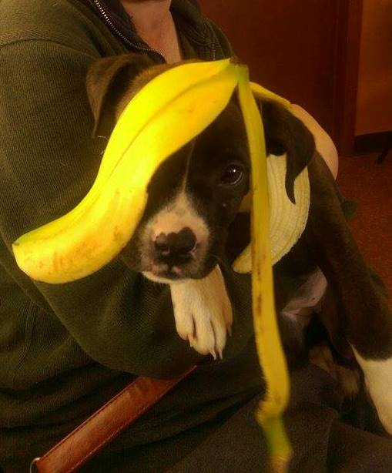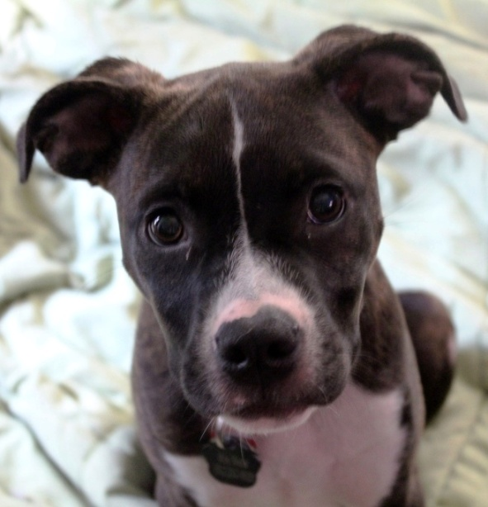

**Dress Up Mabel**

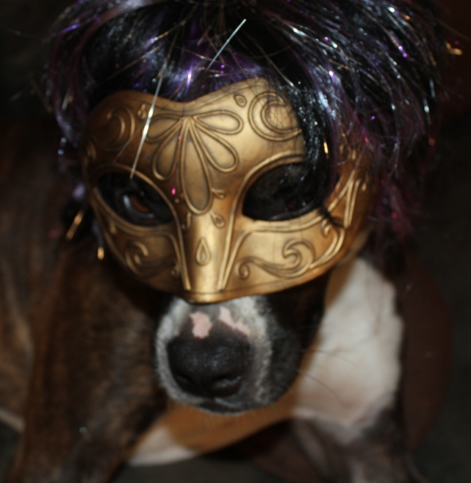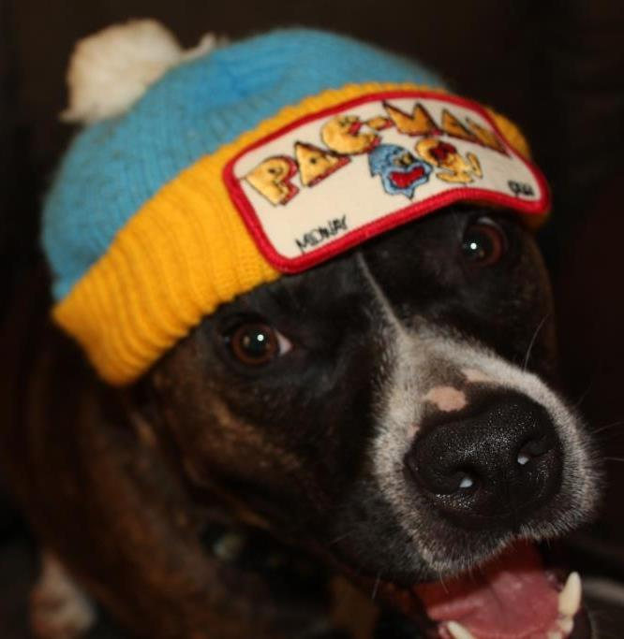

**Covid Mabel**

