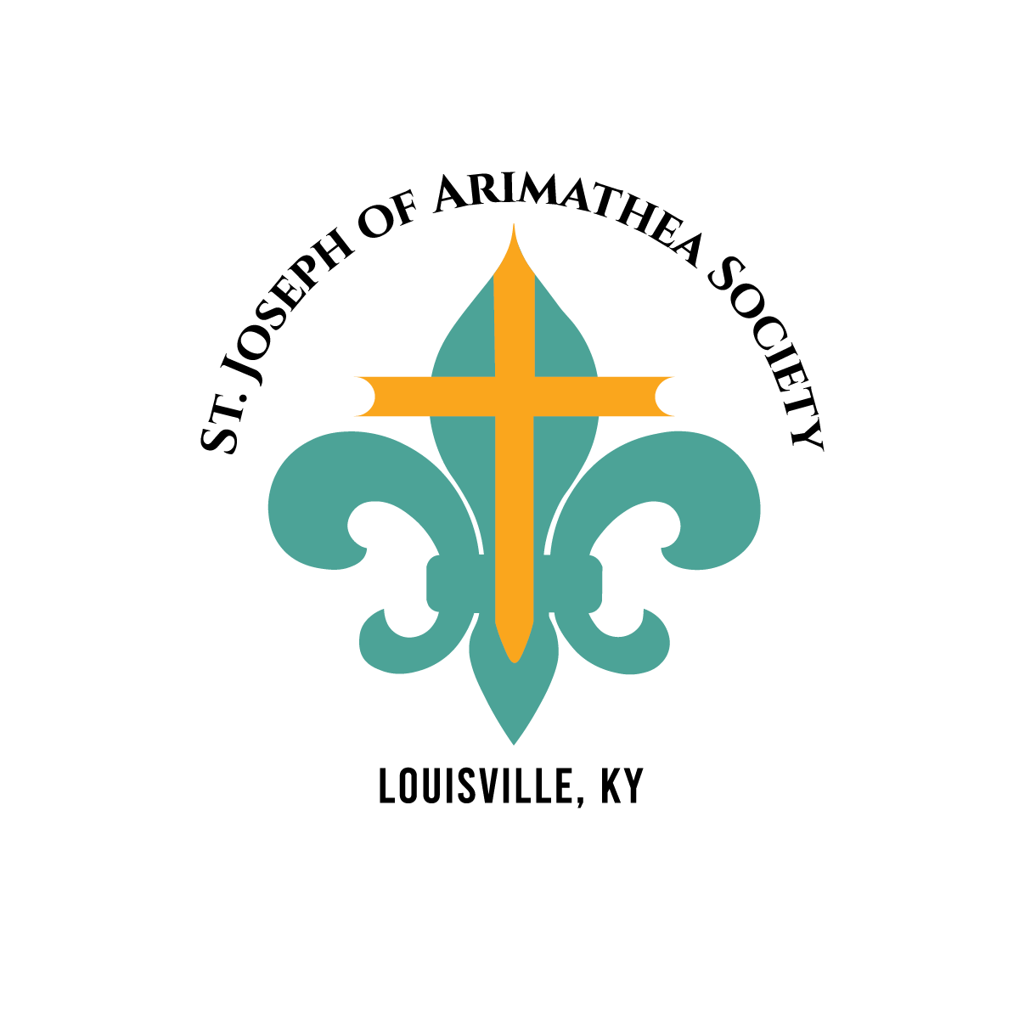  St. Joseph of Arimathea Society is made up of local Catholic High Schools that provide students and Alumni volunteers for all Indigent Burials  Some of Our Community Partners  - Jefferson County Coroner Office  - Louisville Metro Parks  - University of Louisville Hospital  - Norton Healthcare  - Baptist Health  - Cabinet for Health and Family Services  - Kentucky Organ Donors Affiliates  - Kentucky Veterans Cemeteries  - Nursing Home Ombdusman | Who We Are  About Us  Catholic Charities of Louisville serves people in need, especially the poor oppressed, with a wide range of outreaches that assist neighbors of all races, backgrounds, and beliefs. As the social-service ministry of the Archdiocese of Louisville, we serve people in its 24 counties in central Kentucky. We are a member of Catholic Charities USA.  Indigent Burial  Contact Us  Phone: 502-637-9786 x294  Email: jwilson@archlou.org  Web: https://cclou.org/family-support-services/  Catholic charities of Louisville -Indigent Burial  435 East Broadway  Louisville, KY 40202 | Catholic charities of Louisville -Indigent Burial  - Offering Dignity in Death to all those in our community
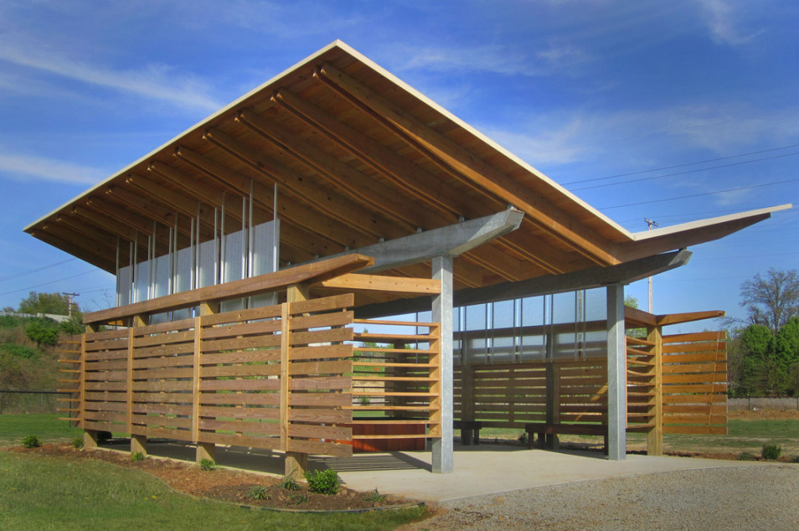  Pavilion at Meadow View designed and built by Colin Drake Design  Mission of Indigent Burial  This one-of-a-kind program provides burial services for individuals in our community who do not have resources or family to provide them. Every individual that qualifies for the Indigent Burial Program receives a dignified and respectful service surrounded by compassionate volunteers and community members.  Our mission is to make sure every individual receives a personalized and respectful service that memorializes their life on earth. We want to ensure, as a community, that everyone who exits this life and enters the next, is surrounded by people that care about them.   | Statistics of Our Program (As of 2023)  Overall Number of Families served: Over 550  Burial at Meadow View: 176  Burials at VA Cemeteries: 40  Cremations: 286  Cremains Burial: 23  Private Burials: 12  Private Cremations: 8  “Our Dead are never dead to us until we have forgotten them” ~ George Eliot  Working with All Religions  As the Indigent Burial Program for the County, we respect all religions and practices.  We work to make sure all customs and ceremonies are respected, and services are carried out in accordance with decedents wishes or standard practices of their religious institutions.    We have connections with all Christian churches, the Jewish, Muslim, and Hindu communities. | 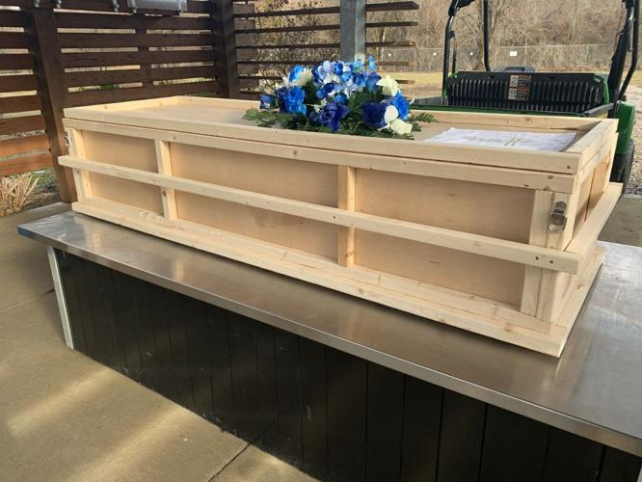  Casket used for Indigent Burials  Our Services  All families have the option of choosing burial or cremation. Cremation is direct and cremains are given back to families. Burials take place at Meadow View Cemetery. Each person buried at Meadow View receives a prayer service, a single plot, and temporary marker.  Local high schools help make concrete headstones for clients and families have the option of purchasing granite stones.  All qualified Veterans are interred at Kentucky Veteran Cemetery Central or Lebanon National Cemetery  We also provide private graves for families of children, which are generously donated by families and volunteers in the community.

